SQL (MYSQL):
- Structured Query Language:
- I.E. Structured Query Language
  - Contains Tables
  - Need to normalize data (replace missing data not containted on in data row)
- Has different table relationships
  - Many to Many (User → Transaction ← Product )
  - One to One ( User → Contact_Data)
  - One to Many (Prodcut → User)
- PROS:
  - Data uses Schemas
  - Relations!
    - One point of updates if related Data (i.e. product ID is updated so transaction now contain updated prodcuts ID)
- CONS:
  - Horizontal Scaling is difficult
  - Vertical Scaling is possible but hard
  - Limitations for lots of (thousands) read and write queries per second.

NoSQl (MONGO_DB (ALSO is AWS Dynmo DB):
- Can store a lot of data in a efficient way
- Collections can have documents that don’t need to have the same schema
  - 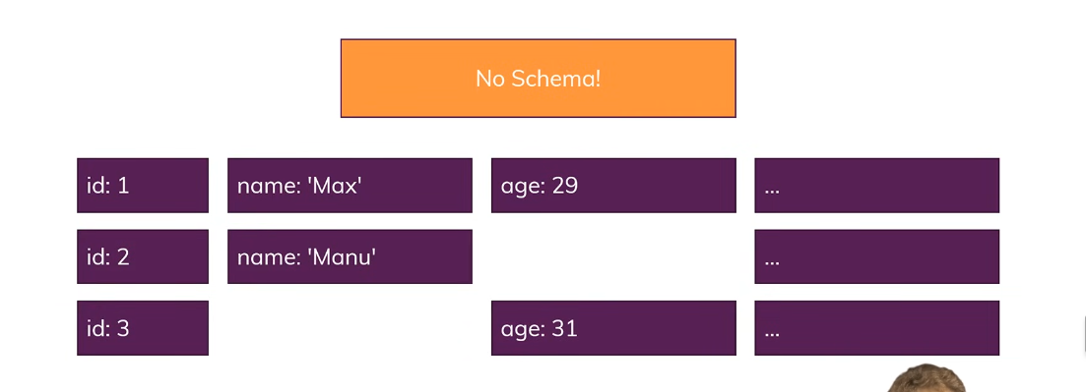
- There aren’t relations
  - There are less relations and the upside is making data retrieval more efficient.
- Pros:
  - Schema-Less
  - No (or very few) Relations
  - Data is typically merged / nested in a few collections
  - Scaling can be done in both directions
  - Great performance for mass read and writes
    - Can be more difficult if update data in multiple collections

Scaling:
- Horizontal: Add More Servers (and merge data into one Database)
  - Hard to map updates for SQL servers at horizontal scaling
- Vertical Scaling: Add more capacity to a single server.
  - There is only so much compute power you can use

